**Model Prediction**

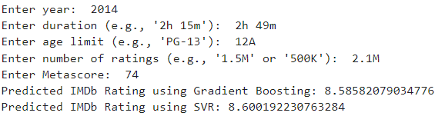

**IMDb Rating**



**Model Prediction**

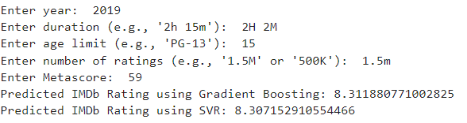

**IMDb Rating**



**Model Prediction**

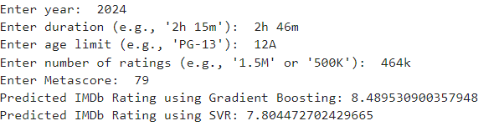

**IMDb Rating**



**Model Prediction**

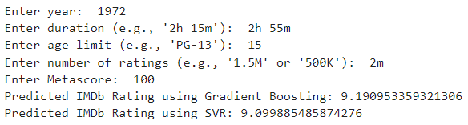

**IMDb Rating**



**Model Prediction**

**IMDb Rating**



**Model Prediction**

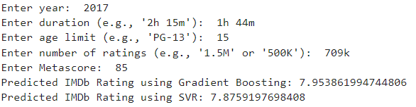

**IMDb Rating**



**Model Prediction**

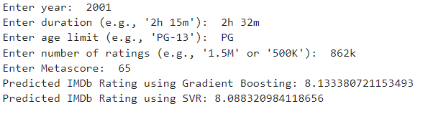

**IMDb Rating**



**Model Prediction**

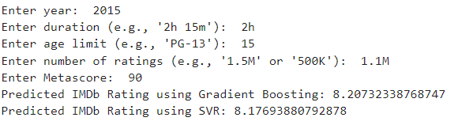

**IMDb Rating**



**Model Prediction**

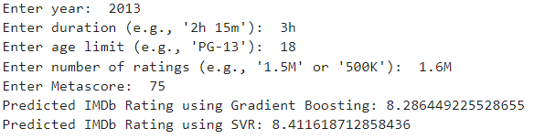

**IMDb Rating**



**Model Prediction**

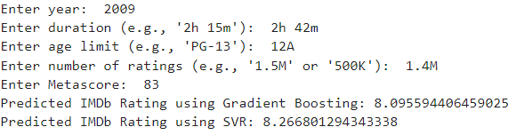

**IMDb Rating**



**Conclusion**

The comparative evaluation between Gradient Boosting and Support Vector Regression (SVR) in predicting IMDb ratings reveals that Gradient Boosting demonstrates superior predictive accuracy in a majority of cases. Specifically, in a test comprising 10 instances, Gradient Boosting provided predictions that were closer to the actual values in 6 instances, whereas SVR achieved this level of accuracy in 4 instances. This outcome suggests that Gradient Boosting may be more effective.